Strategic Transportation Safety Plan Template for Tribes
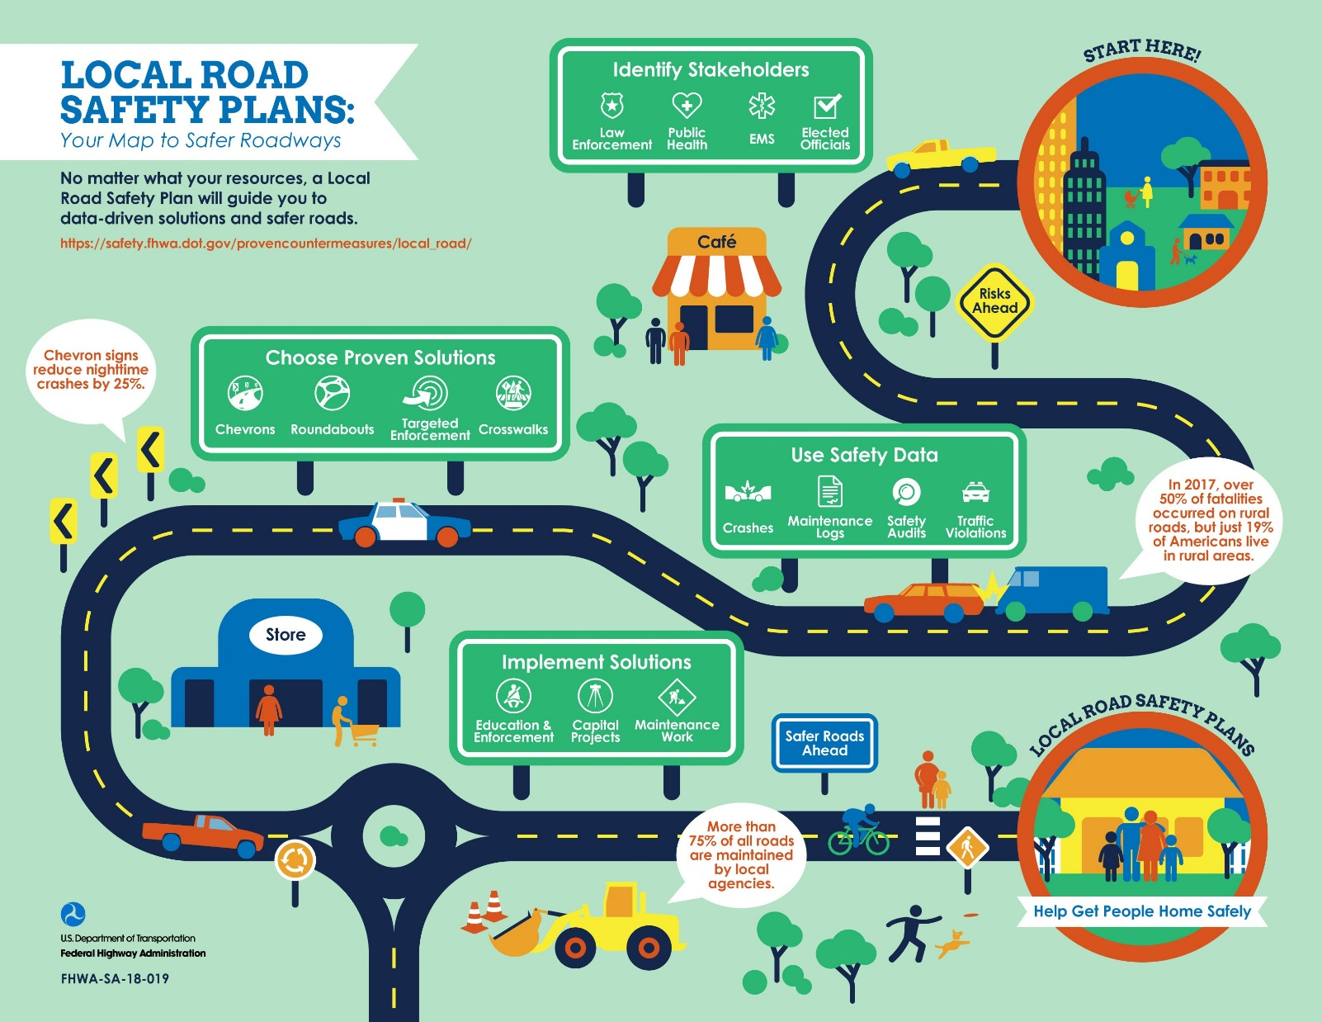

TITLE OF PLAN
AGENCY
DATE

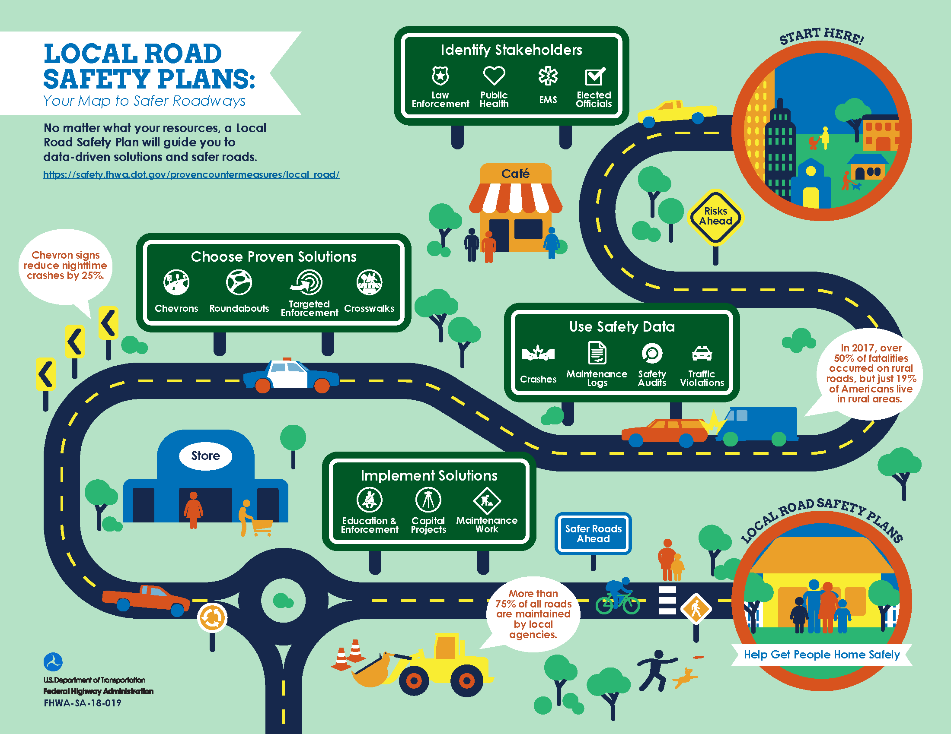
(OPTIONAL) Agency motto, slogan and/or safety message

Transportation Safety Plan Template

Feel free to use this Word document to create your safety plan document. Delete any instructions and examples, and then start writing! Additional resources can be found at:
- FHWA Transportation safety plans Website, http://safety.fhwa.dot.gov/lrspdiy
- TribalSafety.org Safety Plans Resources Webpage, https://www.tribalsafety.org/safety-planning-resources

INTRODUCTION
Briefly describe your Tribe’s commitment to transportation safety through this planning process and the drafting of this document. An introduction can be one or more paragraphs and can be as general or specific as you’d like. It serves two purposes: it gives readers an idea of what the rest of the plan will say; and it provides a reason to keep reading.
For example, you should include a description of the document; define the central concept—transportation safety; and perhaps provide some statistics that you’d like to change enough to take on this planning process.

For example, you might say, “The Tribe is committed to improving transportation safety to reduce the risk of death and serious injury that result from incidents on our transportation systems. This plan tells the story of transportation
safety needs and strategies for our community. Implementation of the plan will improve transportation safety for the Tribe, its people, and its visitors. As part of an ongoing effort to make safety improvements, the Transportation safety plan was developed with input from several safety partners. In the past 5 years, (state some statistic that you want to improve). The Tribe is targeting (cite a goal that will improve this statistic) over the next 5 years.”

VISION & GOALS
Generate interest in the planning process by drafting a vision statement. It can be a team effort. A vision statement is an idealized description of your success. It should inspire, energize, focus, and help you and your partners picture success as you develop the plan.

The best vision statements describe the desired long term, big picture outcomes that are five to ten years away. Summarize your Vision in a powerful phrase. This can greatly enhance the effectiveness of your vision statement. This phrase will serve as a trigger to the rest of the vision in the mind of everyone that reads it. If you are having trouble coming up with your summarizing phrase, try adding after you’ve written the rest of the vision statement.
Here are examples of a vision statement:
- No fatal incidents, no one dies on our transportation facilities
- Save a Life, Save a Nation
- To advance road safety for our Tribe by reducing fatal and serious injuries and improving people’s lives.
- Create a Culture inside and out that promotes and implements Toward Zero Deaths strategies.
Here are examples of goals to support the vision:
- Reduce the number of fatal crashes to Zero by 2030.
- Reduce the number of severe Run off the Road crashes by 50% by 2025.
- Implement proven safety solutions systemically to reduce fatal and severe crashes.
- Increase seat belt usage by 20% for teenage drivers.

SAFETY PARTNERS
Select and identify partners that will be able to provide advice in acquiring and analyzing data, selecting emphasis areas, developing safety strategies, and implementing the final plan. For example, leadership, Tribal Police Department, County Sheriff’s Department, local school, Public Health Department, transportation departments, community groups, local medical professionals, etc.

List of partners here.

- Partner 1
- Partner 2
- Partner 3
- Partner 4

PROCESS
Describe the process you used to develop the plan. This would include identification of team members, public outreach efforts, partner involvement, the timeline, etc.

EXISTING EFFORTS
Describe your efforts, activities, programs, and policies that were already in place or in development to address transportation safety and perhaps led to this planning effort. Identify those that are being evaluated, and those that are beneficial and will continue to be implemented for the foreseeable future.

DATA ANALYSIS and SUMMARY
Use the best available safety data. The best available data may include a police crash reports database, road maintenance logs, traffic violations, the results of a public involvement process, media reports, or other data sources -- depending on what is available for your community.
Note any trends shown by the available safety data and additional questions prompted by the data. Data Analysis involves looking for patterns in crash type, driver factors, roadway features, vehicle factors, or environmental condition. Describe your data analysis using maps of severe crash locations, summaries of crash data, or crash tree diagrams.
You might review state and national statistics that may complement the findings of your data analysis. Each state publishes a Strategic Highway Safety Plan, as listed here: https://safety.fhwa.dot.gov/shsp/other_resources.cfm. A review of national statistics in Tribal areas can be found in the Tribal Transportation Strategic Safety Plan, available at https://www.tribalsafety.org/reports.

If you don’t have ideal safety data include in your plan an emphasis area that aims to improve safety data availability. Tribal governments may benefit from use of the safety data self-assessment tool in the Tribal Crash Reporting Toolkit. The toolkit can be found at https://www.tribalsafety.org/tribal-crash-reporting-toolkit.

EMPHASIS AREAS
Most plans include multiple emphasis areas. Emphasis areas should include three parts: a description, a goal, and strategies. Emphasis areas should describe an opportunity for improvement. Emphasis area descriptions should also explain what information led to the identification of the issue. Strategies should describe the activities that will have an impact on the issue.

Examples of emphasis area that might fit your situation are safety data improvement, roadway departure crashes, crashes on curves, impaired driving crashes, pedestrian safety, intersection crashes, younger drivers, or night-time crashes.

Description of Emphasis Area 1: (What is the problem? Why is this emphasis area strategic?)

- Describe the emphasis area so that an outside reader could understand why emphasis is being placed on this category of incidents.
- Provide a detailed description of exactly what types of incidents the emphasis area covers.
- Provide any additional data that is specific to this subset of crashes.

Goal for Emphasis Area 1:

- Goals provide a short-term measure that can be accomplished.
- Goals enable you to measure success and determine the appropriate time to revise the plan.

Strategies for Emphasis Area 1:

- How will the emphasis area be addressed?
- Strategies should be implementable and should address the emphasis area.
- Who will lead implementation?

Keep this at a high level, individual action plans can be developed for each strategy later. The action plans for each strategy can detail each step that needs to be accomplished to complete the task. Assign a champion to take the lead on implementation of each high-level strategy. You may also want to consider developing a funding plan to help you implement your Transportation safety plan. This could include seeking Tribal Transportation Program Safety Funds or leveraging other funding to complete action items outlined in your plan. It is important that your Transportation safety plan is not based on a particular funding source but instead on strategically addressing your transportation safety needs.

Develop your Emphasis Areas Here.
Emphasis area title:

Description:

Goal:

Strategies:

(Strategy Champion: )

(Strategy Champion: ) Potential Funding Sources:

EVALUATION & IMPLEMENTATION

Describe the process that will be used to evaluate the success of the plan, ensure implementation, and determine when an update is needed.

- How often will the goals be evaluated to measure success?
- When should revision of the plan be considered? (Living Document, every 2 years, etc.)
- Will a committee be formed that meets periodically to oversee implementation?
- Will the Tribal Council hold any departments accountable for progress on the plan goals?
- Is further involvement needed from safety partners from entities outside the Tribal Government?

